DATABASE
labaratory work 3
DML
Task 1: Generate and insert 200 random rows in your airport database.
To randomly generate 200 random rows, we mainly use:
INSERT INTO _ SELECT
FROM generate_series(1, 200) AS i;

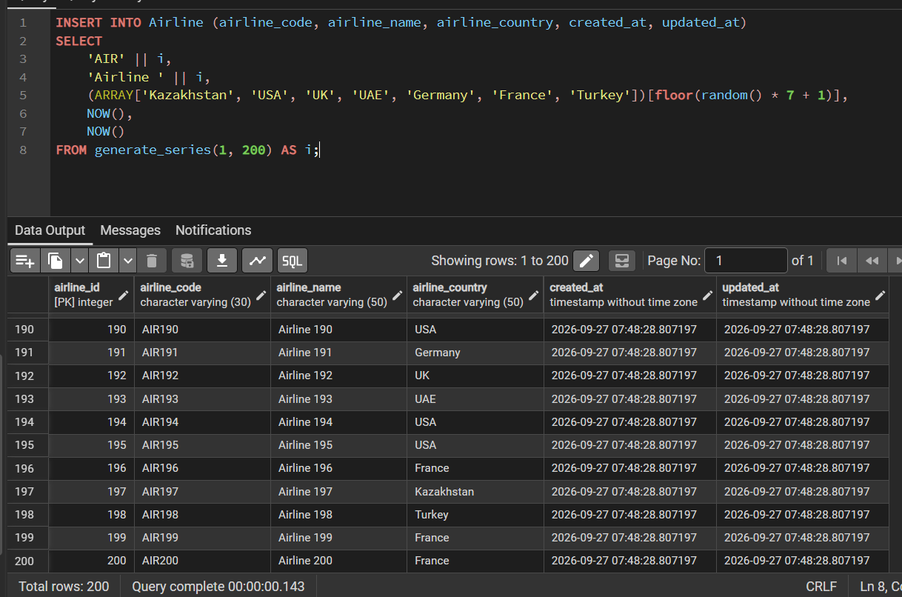
We set i as random number from 1 – 200, and using this random number we set data for columns. Additionally, we also use (ARRAY[])[floor(random()) to pick random value from array. We also can use CASE _ END structure if columns are logically connected, for example country and city are connected, Paris cannot be located in US. So by sub request we can make if/else structure to connect them.

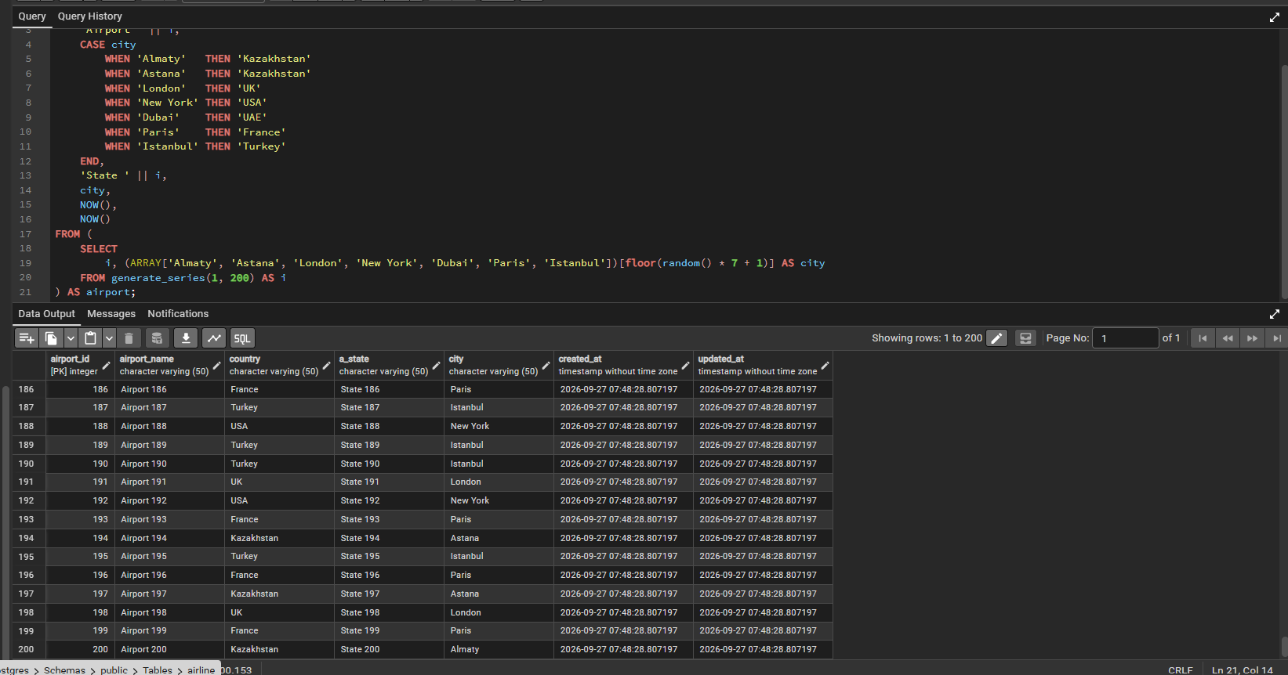
And we repeat this proccess for every table. For datetime: '1990-01-01'::DATE + (random() * 13000)::INT, this structure gives date from 1990 to 2026 , random creates number from 0.0 to 1.0 by multiplying it by 13000 to we get days from 0 to 36 years.
Task 2: Add a new airline named "KazAir" based in "Kazakhstan" to the airline table.
INSERT INTO Airline (airline_code, airline_name, airline_country, created_at)
VALUES ('AIR201', 'KazAir', 'Kazakhstan', NOW());

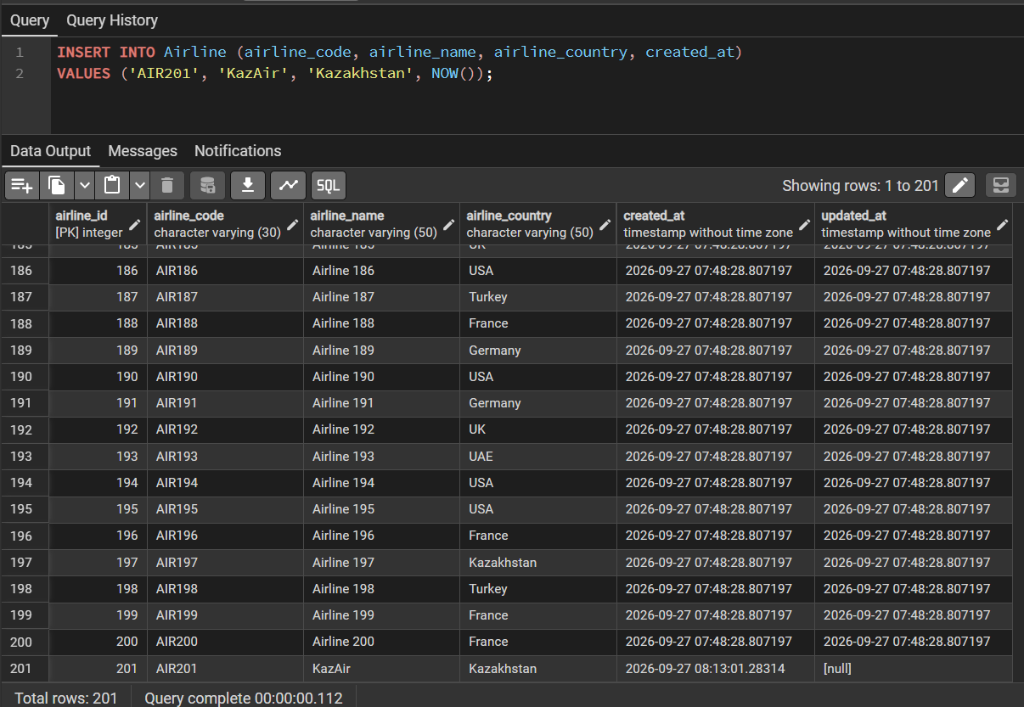
Task 3: Update the airline country "KazAir" to "Turkey".
UPDATE Airline SET airline_country = 'Turkey', updated_at = NOW()
WHERE airline_name = 'KazAir';

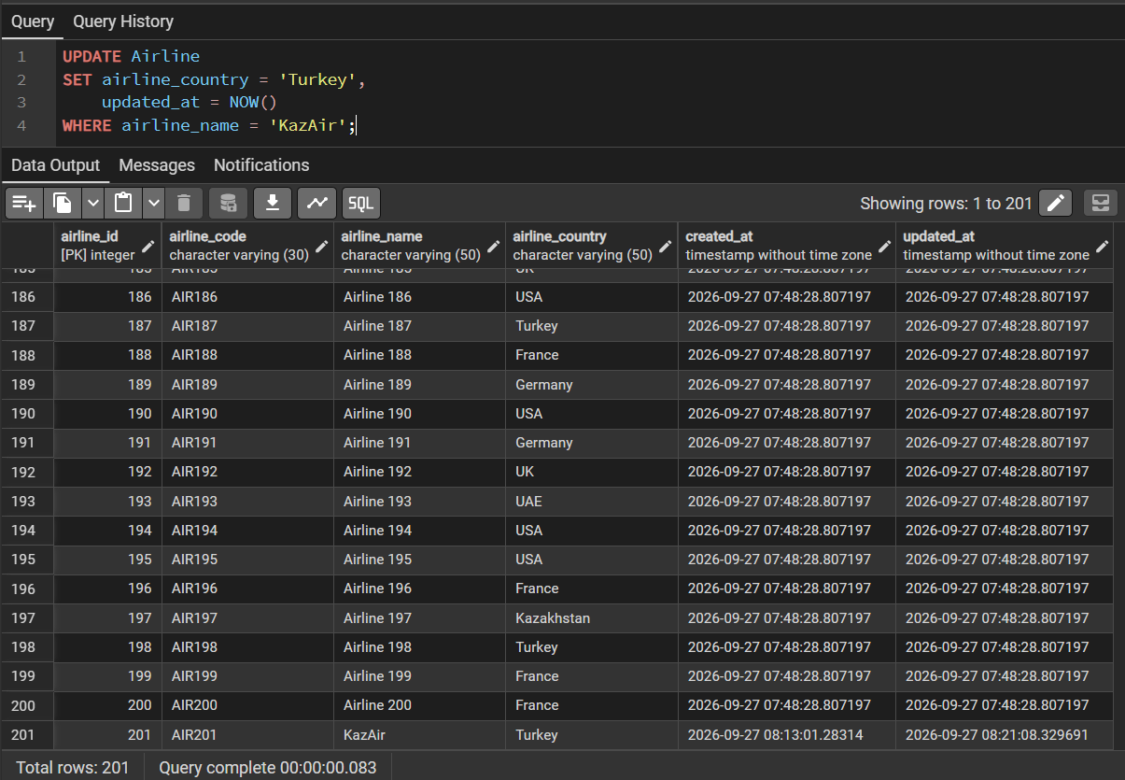

Task 4: Add three airlines at once: "AirEasy" in "France", "FlyHigh" in "Brazil" and "FlyFly" in "Poland".
INSERT INTO Airline (airline_code, airline_name, airline_country, created_at) VALUES ('AIR202', 'AirEasy', 'France', NOW()), ('AIR203', 'FlyHigh', 'Brazil', NOW()), ('AIR204', 'FlyFly', 'Poland', NOW());
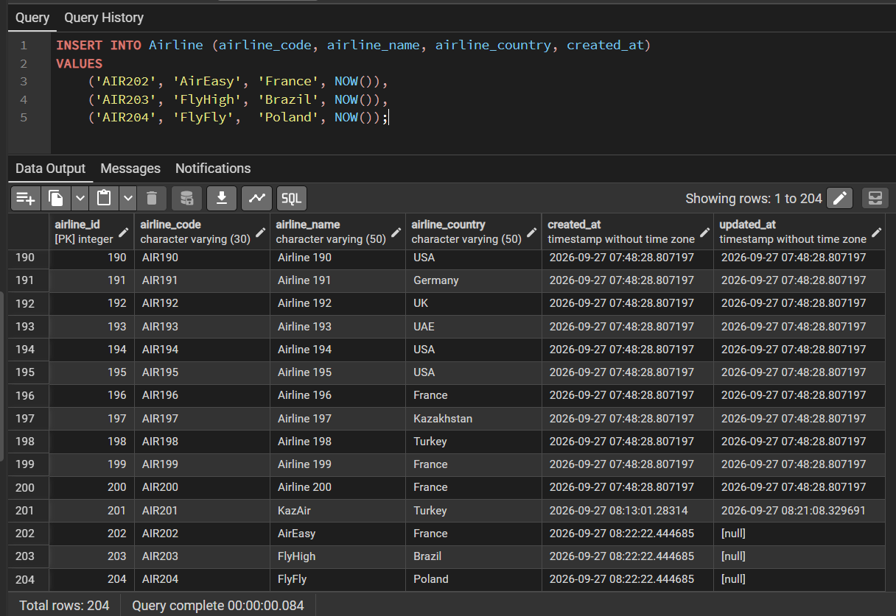
Task 5: Delete all flights whose arrival in 2024 year.
DELETE FROM Booking_flight WHERE flight_id IN (
SELECT flight_id FROM Flights WHERE EXTRACT(YEAR FROM sch_arrival_time) = 2026 );
DELETE FROM Flights WHERE EXTRACT(YEAR FROM sch_arrival_time) = 2026;
Before: I used 2026 because I created arrival time as Now(), so every arrival was from 2026
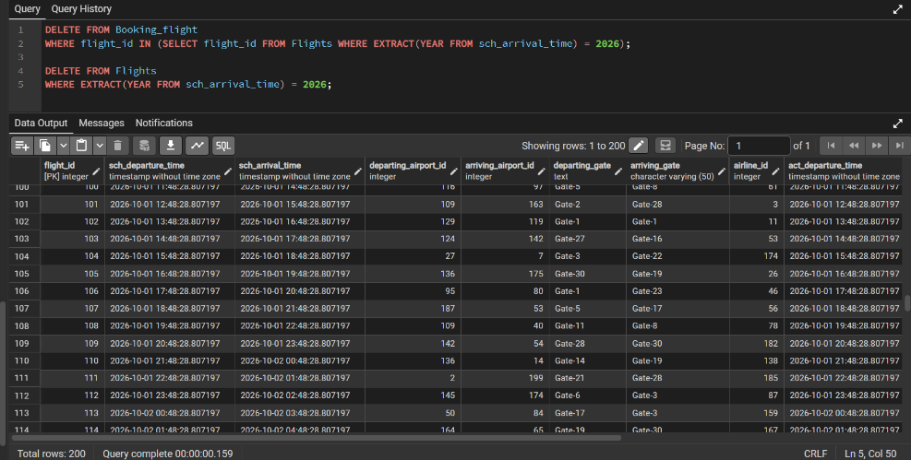
After: because every had 2026 every row got deleted
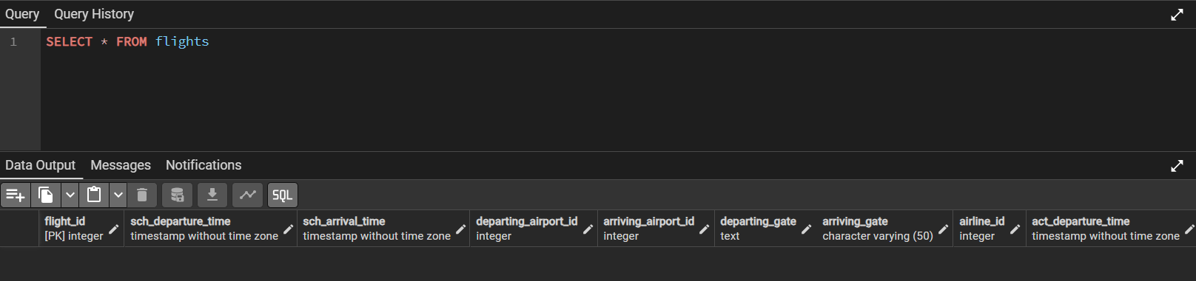
Task 6: Increase the price of all tickets in booking table for flights by 15%.
UPDATE Booking SET ticket_price = ticket_price * 1.15, updated_at = NOW();
Before:
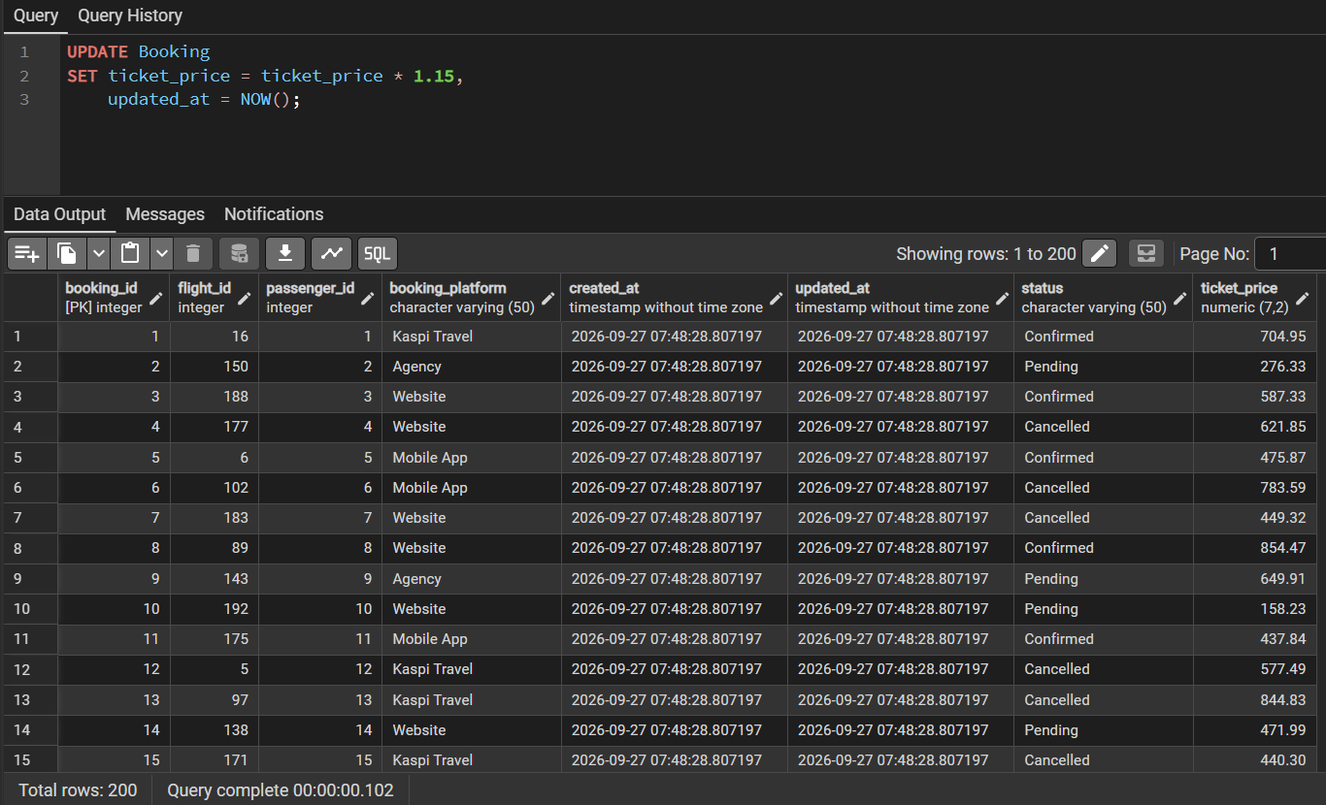
After:
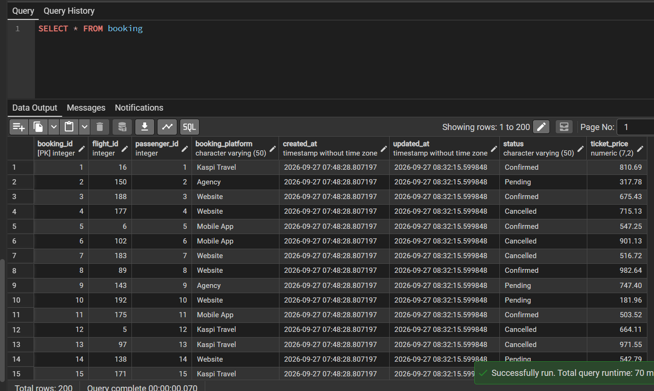

Task 7: Delete all tickets where price is less than 10000.
DELETE FROM Boarding_pass WHERE booking_id IN (SELECT booking_id FROM Booking WHERE ticket_price < 750);
DELETE FROM Baggage WHERE booking_id IN (SELECT booking_id FROM Booking WHERE ticket_price < 750);
DELETE FROM Baggage_check WHERE booking_id IN (SELECT booking_id FROM Booking WHERE ticket_price < 750);
DELETE FROM Booking_flight WHERE booking_id IN (SELECT booking_id FROM Booking WHERE ticket_price < 750);
DELETE FROM Booking WHERE ticket_price < 750;
We need to also delete all datas from tables that dependent on booking. Also, I used 750 because when I created ticket price I set it as 100 – 1000$.

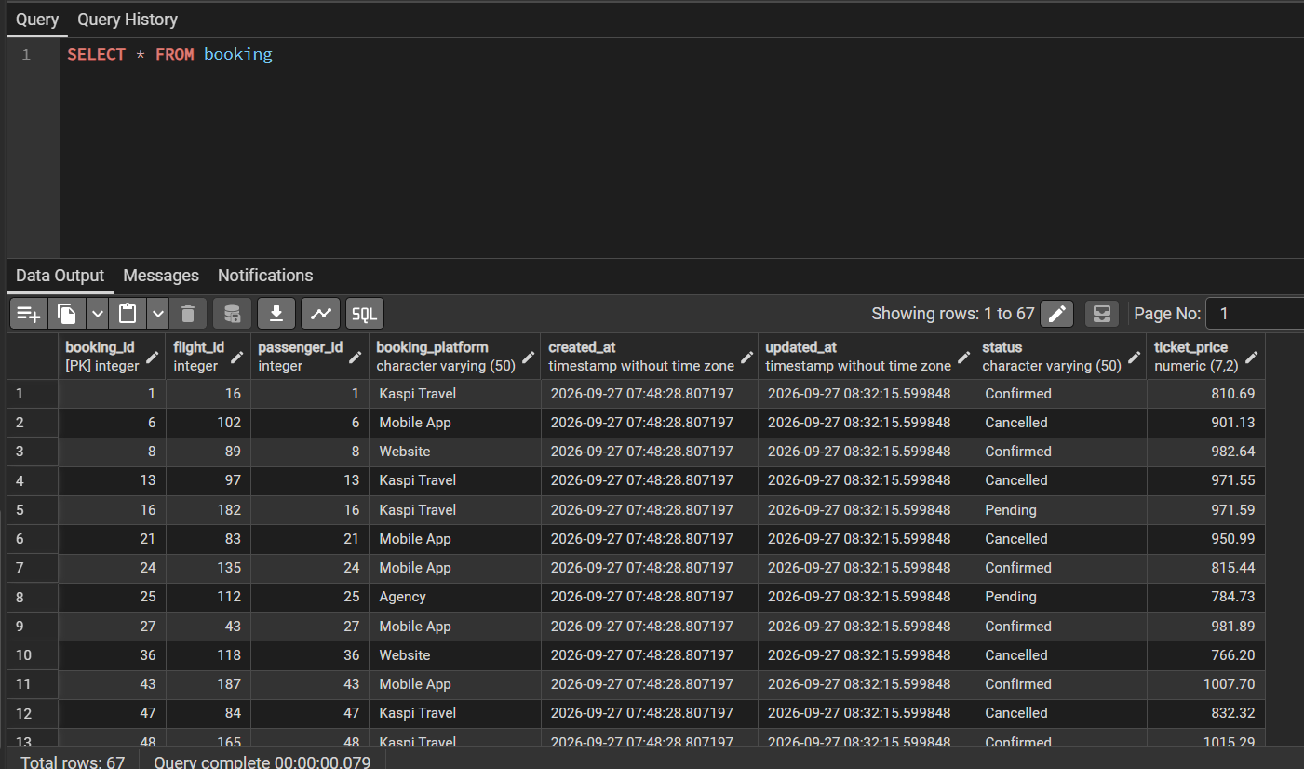

Task 8: Set a default code 'UNK' (Unknown) for any airline in the airline table where airline_code is missing (NULL).
UPDATE Airline SET airline_code = 'UNK',
updated_at = NOW()
WHERE airline_code IS NULL;
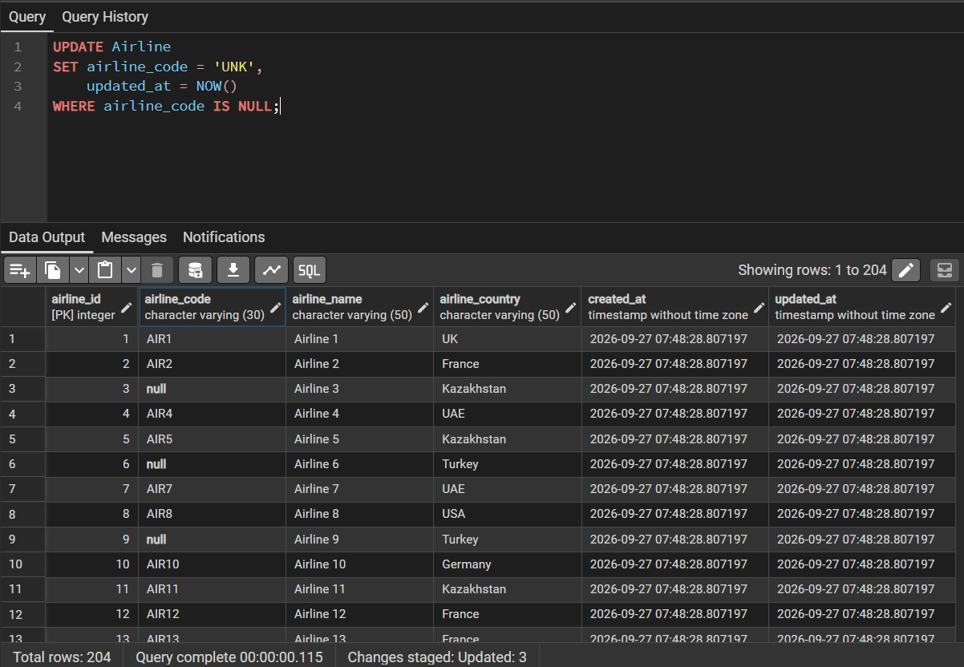
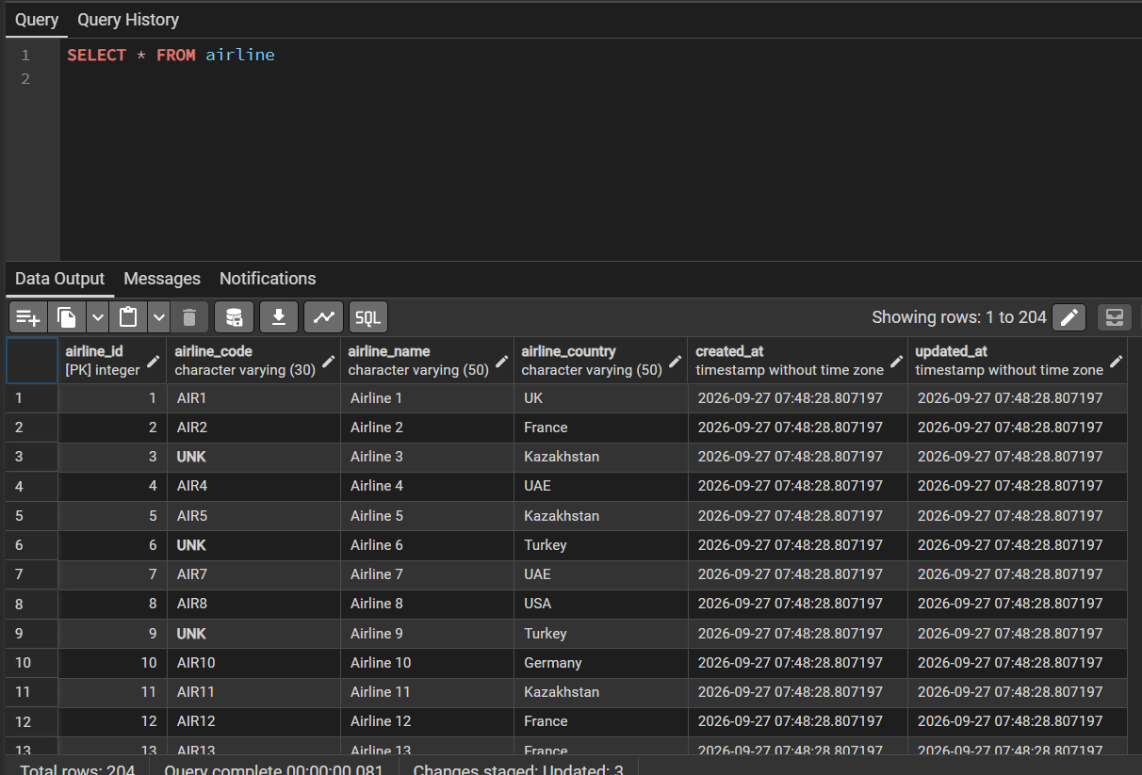

Task 9: Delete all baggage check records created before June 1, 2023, whose result is still 'Not checked'.
DELETE FROM Baggage_check
WHERE created_at < '2023-06-01'
AND check_result = 'Not checked';
Before:
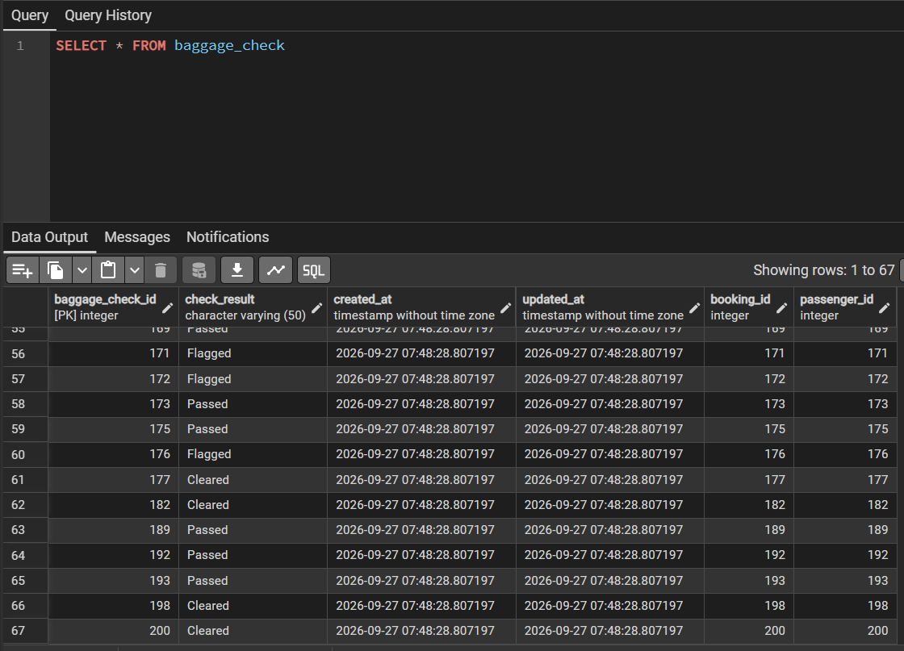
After: Just to see any results I modified input:
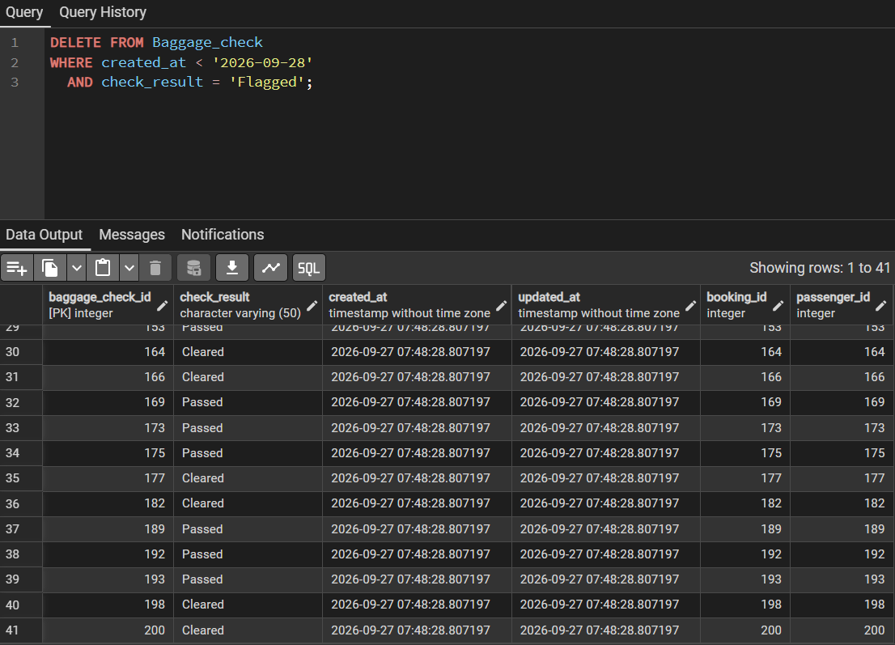

Task 10: Delete all entries from the airport table where state is missing (NULL) and the city is either 'Mlawe' or 'Kepuh'.
DELETE FROM Airport
WHERE a_state IS NULL
AND city IN ('Paris', 'Istanbul');

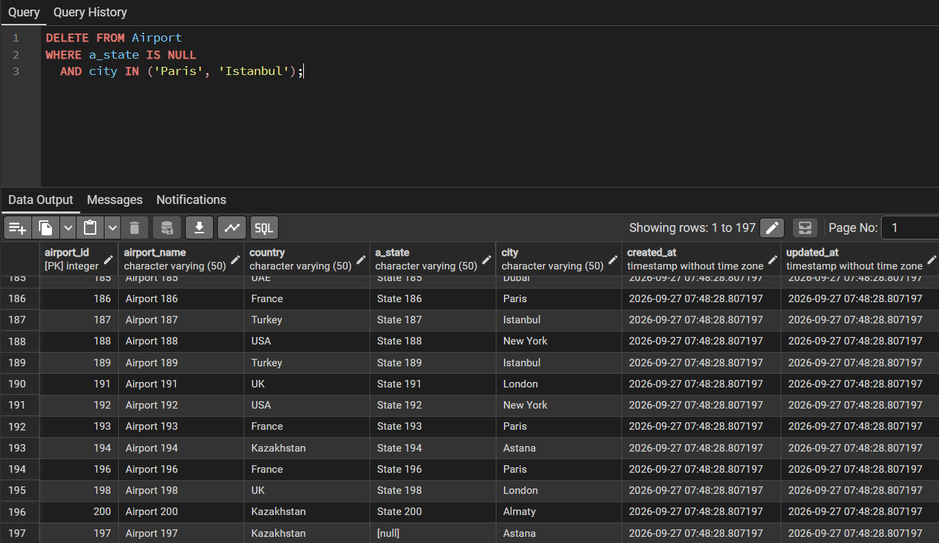
Task 11: Insert a new unchecked baggage inspection record and immediately return its newly generated baggage_check_id and created_at timestamp.
INSERT INTO Baggage_check (check_result, created_at, updated_at, booking_id, passenger_id)
VALUES (
'Not checked',
NOW(),
NOW(),
1, 1
)RETURNING baggage_check_id, created_at;

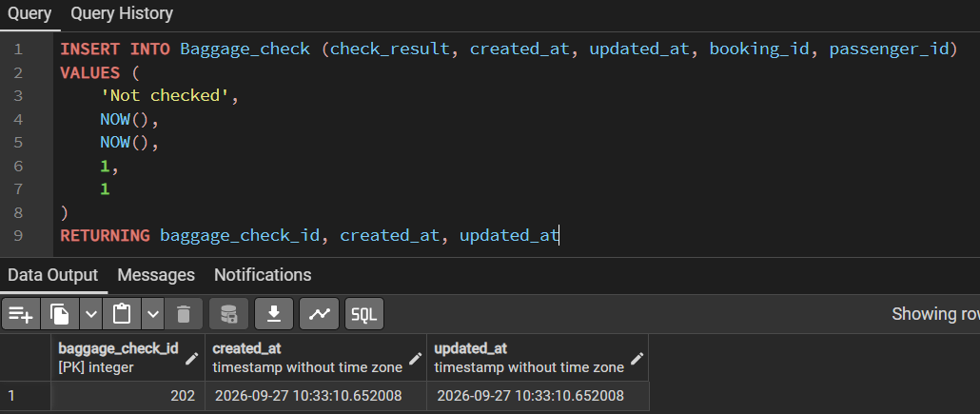

Task 12: Convert all country names in the airline table to uppercase to ensure data consistency.
UPDATE Airline
SET airline_country = UPPER(airline_country),
updated_at = NOW();
Before:
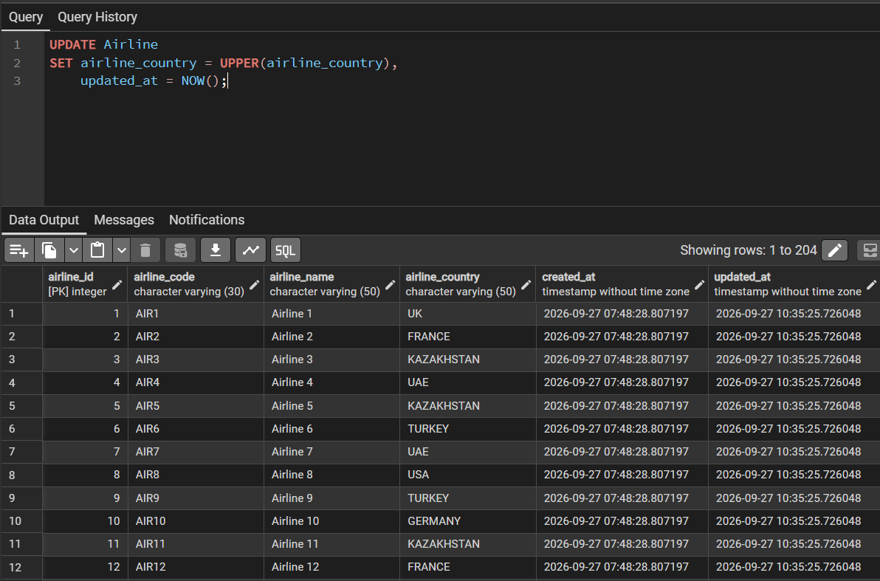
After:
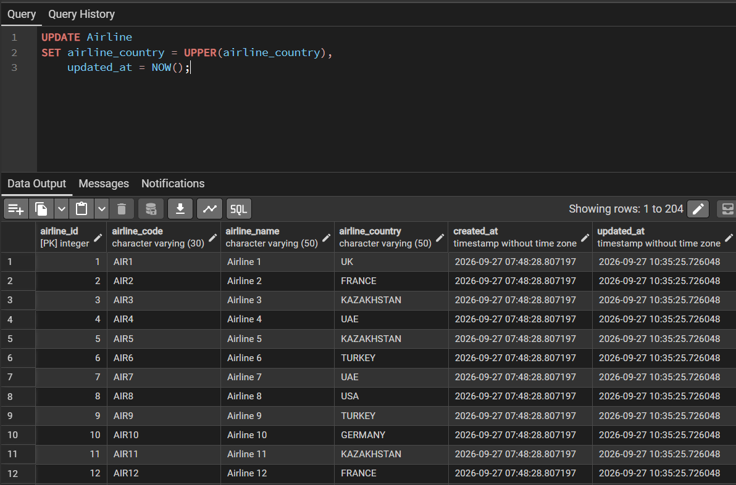

Task 13: Update both the name and country for the airline with airline_id = 5. Set the name to 'Global Airways' and the country to 'United Kingdom', while updating update_at to the current date.
UPDATE Airline
SET airline_name = 'Global Airways',
airline_country = 'United Kingdom',
updated_at = NOW()
WHERE airline_id = 5;
Before:
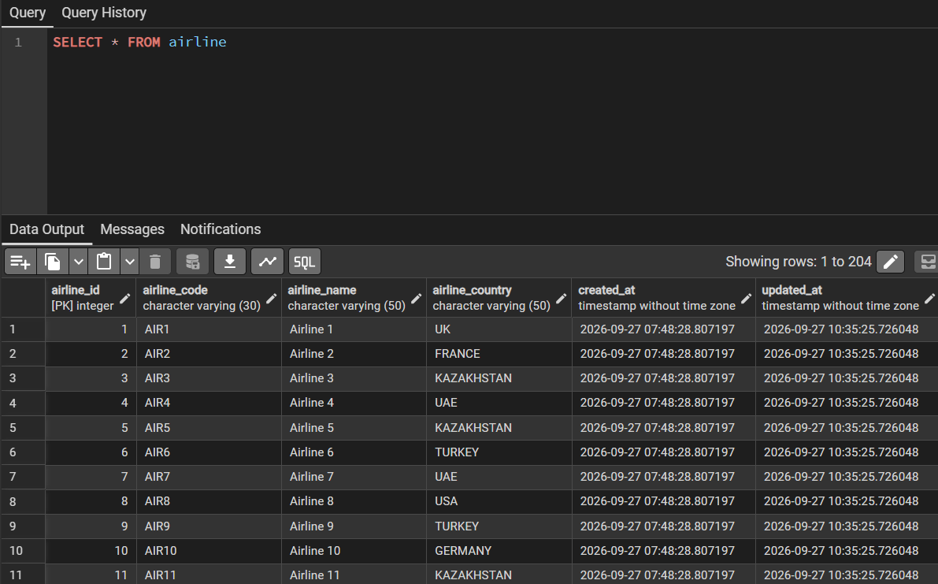
After:
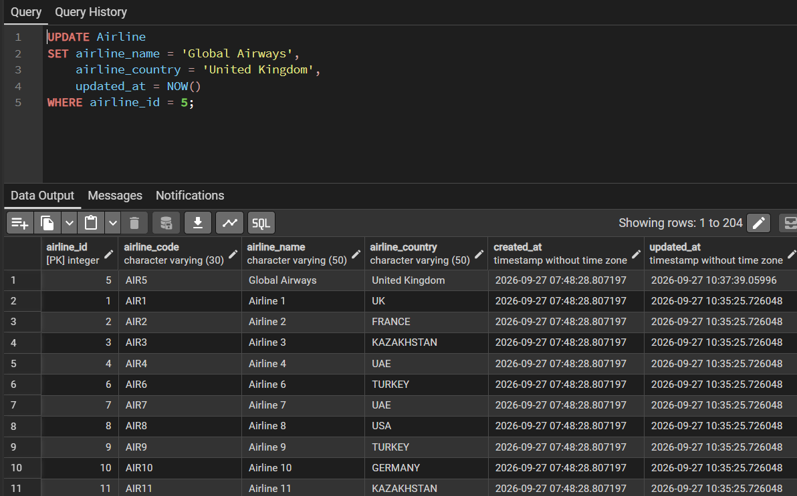

Task 14: Set the state field to 'Capital District' for airports located in specific cities: 'Astana', 'London', and 'Tokyo'
UPDATE Airport
SET a_state = 'Capital District',
updated_at = NOW()
WHERE city IN ('Astana', 'London', 'Tokyo');
Before:
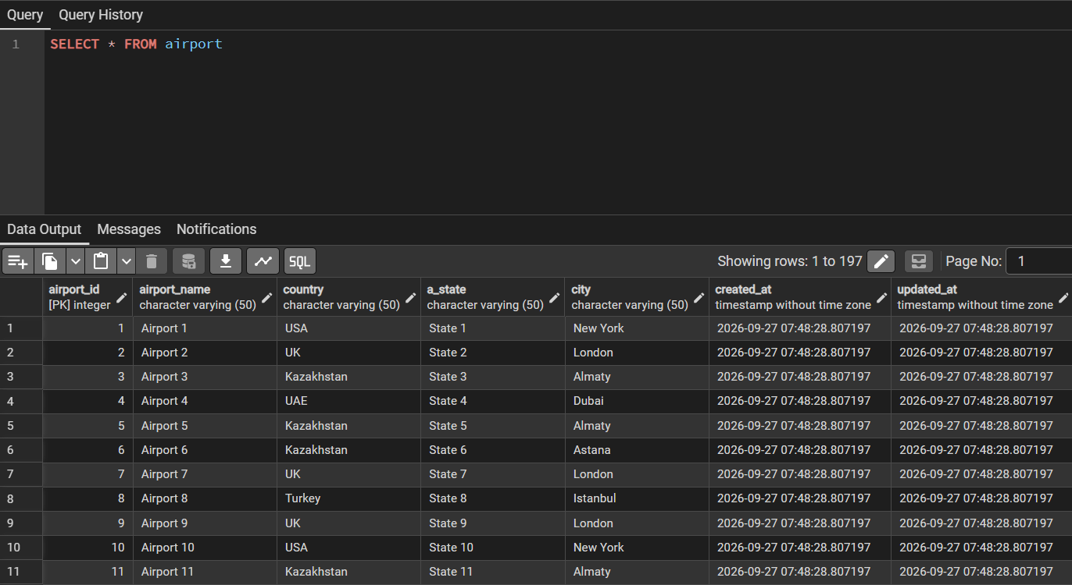
After:
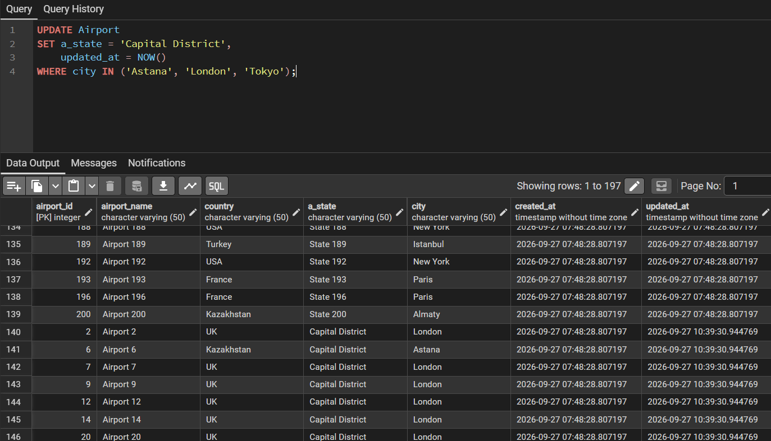

Task 15: Mark all baggage check records (baggage_check) created in March 2024 with a status of 'Not checked' as completed ('Checked')
UPDATE Baggage_check
SET check_result = 'Checked',
updated_at = NOW()
WHERE created_at >= '2024-03-01'
AND created_at < '2024-04-01'
AND check_result = 'Not checked';

